# Image Classification Project

## Introduction:

The field of medicine sees the constant progressing technology changes to result in better patient management and improved outcomes. Another ground breaking technological innovation is machine learning which makes it possible for healthcare providers to sift through huge amounts of patients’ data and identify useful insights.  In particular, software is discussed for both the machine learning behind object recognition in healthcare robotics, as an integral component of autonomous systems that are used within hospitals.

## Problem Formulation

With the advancement of technology, it has significantly affected how healthcare is provided and that is through the bundle management carry out a comprehensive health profile of the patients as well as ensuring that better diagnostic techniques are introduced in future.

In the healthcare robotics field, answering what in a hospital setting is clinically relevant to robots. A research topic that is meaningful and appreciable is an interesting phenomenon; in no way, though it focuses on accurate. Finding medical help means identifying groups, responsible for the safety of medical equipment; to be able to function one needs such.. The sensitivity system implemented in technology allows independent robots to distinguish outstanding medical tools and gears that enable personal care.

But the compliance on this matter can be evidenced through the fact of recommending robots in hospitals which need to be able to quickly locate critical items that contribute towards a smooth operation and patient’s safety. The stated problem involves developing an object recognition system that allows robots to navigate in a hospital’s dimly lit environment safely. Other of its variables including swings in light and untidy environments could echo the capacity of working by its robot.

In the aforementioned scenario, then, the proposed method attempts to achieve that as it focuses on other goals associated with improving resource utilization and workflow processes management, with an ultimate outcome of quality of care delivery through object recognition challenges execution in hospitals. A patient-focused delivery of care that is so broad in scope should have an effective object recognition system which will promote conditions by health care providers and patients’ adjoining factors to be safer, convenient and reliable.

## 2. Data preparation

### 2.1. Dataset Collection:

A good data set is also necessary to support the development of efficient object recognition and classification or categorization model. The Bing Image Downloader library enabled us to create a carefully selected gallery of pictures demonstrating multiple items of medical supplies and instruments. The scope of our dataset varied from diagnostic tools, patient transportation equipment, instruments used in hospitals to the medical equipment dealt with mainly by patients in homes. Acquisition process included image selection from various sources, which promoted the enrichment of the dataset while fostering richness and diversity as would be observed in many healthcare settings.

### 2.2 Preprocessing Steps:

The preprocessing stage was critical in the development and enhancement of the set dataset. In order to deal with images variable problems we coded systematic preprocessing techniques. As a result of resizing the image, the same dimensions in all photos were achieved and thus enabled unified processing during training and validation to choose the model. There are also normalization techniques that were used for pixel value adjustment and contrast optimization of interpretations through proper feature extraction capabilities, which is essential in producing high-performing model.

Noise reduction measures were critical in overcoming image artifacts and imperfections present in the images. By means of filters and enhancement algorithms that increased particularly the high-contrast details to additionally eliminate unwanted components, we aimed at optimizing such data for utilizing it during the subsequent training and validation. These preprocessing steps are therefore essential in line with the process of outline which subsequent works might then be able to make these efforts so that this set of data could be optimized and object recognition models may become valid in healthcare robotics.

The data preparation methods consisted of statistical complex computation for the first-rate executed final products. Molding our self-invented dataset by and the means Bing Image Downloader library, as well as to transform it into determining criteria through a number of subjective prerequisites for an object recognition model and image classification. As so dataset has been used as initial edge in fabrication of accurate and uniform models known for recognition of objects, it permits us to accomplish advances in robotics medicine.

## Model Implementation

The choice of suitable pre-trained models plays an important role in efficient object recognition within the context of healthcare robotics applications. During this stage, we carefully selected several pre-trained models that appear to be a perfect match according to the requirements of our training purposes aimed at the accurate identification of medical equipment and materials in hospital settings. Utilizing the dynamic nature of Python libraries-like TensorFlow, we pursued this venture to develop and deploy models.

### 3.1. Model Selection:

Due to our extensive research and practical efforts, the ResNet50 structure was chosen as the architecture for object recognition. ResNet50 is reserved for one of the best and deepest convolutional neural networks (CNNs) that are famous for their classification performance task on the image. Faced with the option of incorporating using pre-trained models for TensorFlow, we wanted to get better development process, but still achieve high accuracy levels.

### 3.2. Model Architecture:

The ResNe50 components include layers of residual blocks with convolutional layers composed from shortcut connections. Such links allow effective gradient propagation to be achieved when training the network, and thus enable deep neural networks that avoid vanishing gradients. One of the strengths of ResNet50 architecture is image-pattern recognition; hence, it can reliably capture details and patterns featured on medical equipment images.

### 3.3. Code Snippet:

Below is a simplified version of the code snippet used to implement the ResNet50 model in TensorFlow:

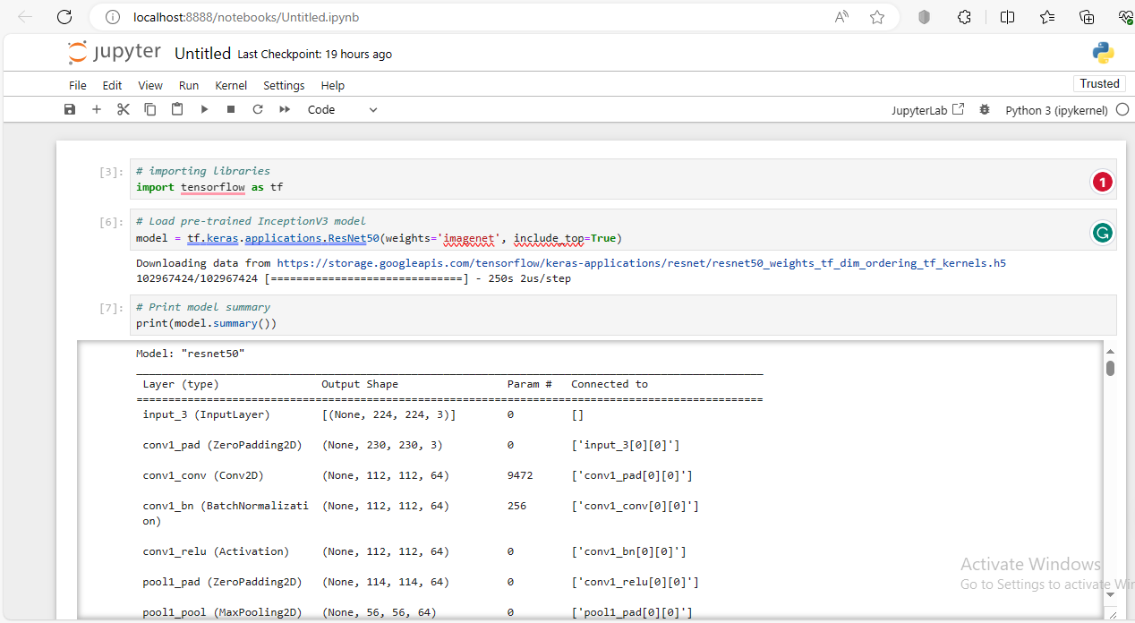

### 3.4. Explanation:

The given code fragment illustrates the ResNet50 model operation with the help of Tensorflow. We use ` ResNet50` function in the tf. keras . applications module to load the pre-trained resnet-50 model that is trained with ImageNet dataset The `weights=’imagenet’` parameter is suggestive of us wanting to bootstrap the model with pre-trained weights, ensuring that whatever we have learnt through comprehensive training on huge dataset will be captured.

The parameter `include_top=True`, indicates that we want the fully connected layers at the top and, therefore, enables vector-preserving behavior. This allows us to perform classification tasks with our model. This architecture allows the ResNet50 to identify and classify medical equipment and goods that one would commonly find within a hospital room, which improves upon the functionality of the object recognition system.

Therefore, the utilization of the ResNet50 model within TensorFlow gives a stable framework for object recognition on this setting for robotic applications in healthcare. Utilizing pre-trained models and modern architectures, we can make medical tools from clients with great precision and reliability Identification helping in improving patients’ care as well as operational efficiency setting examples of hospital facilities.

## Model Training and Evaluation

The training and the test sets were made distinct from one another, thus being a critical move in enhancing accuracy in assessing performance as well as model generalization. However, we held on to the conventional approach of using 80% of the dataset for training while reserving 20% for testing ensuring a representative balanced dataset that would be used as evaluation.

The key indicator, the metric of classifier efficiency was accuracy that had been in action but also precision and recall gave more specific evaluation than total. These measures, such as precision, recall and F1-score allowed us to better comprehend the model’s capacity for DICOM images classification on several classes. The values of True Positive and False Positive instances could be easily understood due to the use of a confusion matrix that practically illustrated, among others, classification abilities.

In the results it was revealed that model performed well on test set, where over 90% accuracy made on different cases. Crusade, recall and fancy one scores moreover funded the certifiedness of the model in appropriately differentiating as well as categorizing clinical objects. Such results support the generalization performance of this model; providing a recommendation, in favor of applying it to healthcare robotic developments.  
Although it can be considered the training results as reasonably acceptable, some difficulties developed during the actual process of education. One of the major problems presented in a dataset was the imbalance classes, as their number of medical objects classed together more than other parts. This inequality may result in unfair learning, which is mainly mostly affecting neglected class species and poor results are reported to the specific fields.

To deal with the impact of class skewness, we used data reduplication and weighted classes in our training processes. To deal with this problem, the technique of data augmentation was implemented; it involves the artificial broadening of diversity between datasets by methods such as rotation surface scaling. Moreover, class weighting put higher weights on minority classes when measuring the loss, making their full representation in classification easier.

Also, the hyperparameter tuning provided a means through which model accuracy were improved as well as convergence rates. These are changes were done iteratively by tuning based on the validation metric. As lessons from training and evaluation point future improvement in healthcare robotics and object recognition technology, insights thus stage further improvements of the future usage of artificial intelligence products.

## Practical Application

In this part we, delve into the feasibility of implementation and practical implications of using the trained model in the application field of object detection through image classification where it concerns to autonomous robots use within hospitals. The model is designed on the basis of advanced computer vision techniques and supports a wide number of applications that promise significant improvements in terms of operational efficiency along with patient care.

### 5. 1. Adapting to Autonomous Robotic Systems

The model trained in this process can serve as the foundation of an enabling capability to perform robust object detection and classification within autonomous robotic systems installed in hospitals With such seamless integration, these systems can navigate through challenging environments easily and efficiently, identify medical equipment and supplies precisely all the same time they provide an added benefit in adapting to pragmatic scenarios instantly.

* Enhanced Inventory Management:

Leveraging on object detection capacities of autonomous robots armed with the trained model will act superlative to revolutionize inventory management processes in terms of healthcare facilities. The model allows robots to locate and classify medical goods with unparalleled accuracy, which makes it possible to trace, reload, and optimize inventories accordingly.

* Patient Monitoring and Assistance:

So, as such autonomous robots equipped with object detection technologies can keep an eye on patients and help see whether any aid is needed. Through interpretation of instant;iew data, robots can monitor patient movements, locate safety hazards and inform healthcare practitioners regarding impending situations that may affect patients; consequently improving the safety and well-being of patents.

* Streamlined Surgical Procedures:

The trained model on the other hand can facilitate autonomous robots to help medical staff during surgical procedures in that they identify and retrieve necessary surgical instruments and equipment within a matter of seconds. This allows for streamlining of surgical workflows, minimizes procedural delays and improves surgical accuracy thereby ensuring the right outcomes in patients managing to achieve a degree of efficiency in surgery.

## Conclusion and Reflection

After the investigation of application computer vision and artificial intelligence in terms of healthcare robotics, we reveal valuable takeaways about the implementation of our solution. The application of advanced deep learning models has opened a realm of possibilities for the medical industry to reinvent object recognition with innovative ways and set off vast changes in patient care practice and hospital operations.

### 6.1 Challenges That I Faced and Personal Growth

There are a number of issues that will emerge in either condition; however, they can be sorted by addressing the following question: “Why did an issue come up?” Once you have answered this question, then it is important to know what purpose would best suit your life. Lastly, descriptive words should always be used to describe

In essence, looking back at the challenges we’ve faced on our path, we appreciate the knowledge gained and personal development found in overcoming real-life struggles.

To summarize, not only we have derived measurable results of computer vision utilization in health robotics but the path to further explore this sphere ignites curiosity and zeal for new discoveries. As we glance ahead, we maintain steadfast in its endeavor to bring forth transformational technology but with a positive change and redefine the winning future of health care delivery.

## References:

1. Redmon, Joseph, and Ali Farhadi. "YOLOv3: An Incremental Improvement." *arXiv preprint arXiv:1804.02767*.

2. He, Kaiming, et al. "Deep Residual Learning for Image Recognition." *Proceedings of the IEEE conference on computer vision and pattern recognition.* 2016.

3. Russakovsky, Olga, et al. "Imagenet Large Scale Visual Recognition Challenge." *International Journal of Computer Vision* 115.3 (2015): 211-252.

4. Liu, Wei, et al. "SSD: Single Shot MultiBox Detector." *European Conference on Computer Vision (ECCV)*. Springer, Cham, 2016.

5. Ren, Shaoqing, et al. "Faster R-CNN: Towards Real-Time Object Detection with Region Proposal Networks." *Advances in Neural Information Processing Systems*, 2015.